DETECTING AI GENERATED IMAGES WITH CNN AND INTERPRETATION USING EXPLAINABLE AI
Scope and Limitations
Department of Computer Science and Engineering, [COLLEGE NAME]
Batch C14 (CSE-C) · Academic year [ACADEMIC YEAR]
Table 1: Project team
S.No. | Student name | Roll number
1 | Ponugoti Viduranandan | 23K91A05J5
2 | Naina Baherji | 23K91A05G9
3 | Likki Pranathi | 23K91A05D2
4 | Motasani Sathish | 23K91A05G0

Project guide: M Thanmayee
Chapter and section numbers quoted in the text (for example Chapter 8 or Section 6.2) refer to the full project report, 17.Final Document. Figures and tables in this document are numbered from 1.

1. SCOPE
The scope states what the delivered system covers and, just as importantly, what it deliberately leaves out. Everything under "in scope" was built and measured; items under "out of scope" were not attempted and no result is claimed for them.

1.1 In scope
• Binary classification of a single still image as REAL or AI_GENERATED, with a probability and a confidence word (High at 0.85 or above, Moderate at 0.60 or above, otherwise Low).
• Four CNN routes (EfficientNet-B0 A1 and A2, ResNet50 B, MobileNetV3-Large C) fine-tuned from ImageNet weights, fused in logit space with two gates.
• Grad-CAM heat maps for three routes (A1, B, C) on the predicted class, shown as overlays on the uploaded image.
• A robustness check: the image is re-classified after JPEG q=60, a half-size resample and a Gaussian blur, and the agreement k/n is reported.
• A local web application: Flask JSON API on port 8414, React interface on port 5414, a demo sign-in with a signed 12-hour token, PNG, JPG, JPEG and WEBP uploads up to 10 MB.
• Training and evaluation scripts, a class-balanced CIFAKE subset, a cross-domain probe set, and the metric artifacts that the Insights page displays.

1.2 Out of scope
• Video, audio and face-swap detection. The base paper's domain (faces in video) is not covered.
• Identifying which generator produced an image, localising edited regions inside a real photograph, or detecting partially generated (inpainted) images.
• Training on the full 100,000-image CIFAKE training set, on several generators, or on high-resolution images; only a 6,000-image training subset was used.
• Multi-user accounts, a database, per-user history, hosting on a public server, or processing of images in bulk.
• GPU training or inference, quantisation, and mobile deployment.
• Legal or forensic certification: the output is a statistical estimate and not proof of origin.

1.3 Users and environment
The intended user is an analyst, student or fact-checker who runs the tool locally and uploads an image to obtain a second opinion with an explanation. All measurements were made on one machine (Intel Core i5-12500, 6 cores and 12 threads, 15.7 GB RAM, no GPU, Windows 11, Python 3.11.9, torch 2.14.1 for CPU). The upload limit is 10 MB and images smaller than 8 x 8 pixels are refused.

2. ASSUMPTIONS
The results and the design rest on the following assumptions. A reader who cannot accept one of them should treat the corresponding result with caution.
1. CIFAKE labels are correct: 60,000 CIFAR-10 photographs are taken as REAL and 60,000 Stable Diffusion v1.4 images as AI_GENERATED, as published by the dataset authors [8].
1. A class-balanced random subset (seed 42) represents the full dataset well enough to rank the routes; the validation and test subsets are disjoint from the training subset.
1. The uploaded image is a single, unedited still in RGB; images with an alpha channel or palette are converted to RGB before analysis.
1. The deployed models are the checkpoints produced by the documented training run; the fusion weights (0.35, 0.15, 0.25, 0.25) and the gate settings (2.5, 2.5, 0.75) are fixed defaults.
1. The user runs the application on a trusted local machine; the demo sign-in is a convenience and not an access-control mechanism for a shared server.
1. Test-time degradations (JPEG q=60, half-size resample, 5x5 blur, Gaussian noise sigma 6) stand in for what social platforms do to images; they were not copied from any particular platform.

3. LIMITATIONS
The limitations below are those that most affect how the reported numbers should be read. They are stated as findings, not apologies.
1. Small, low-resolution, single-generator data. The models saw 6,000 of the 100,000 CIFAKE training images, for three to five epochs, because training is CPU-only. CIFAKE images are 32 x 32 JPEG and come from one generator (Stable Diffusion v1.4). The in-domain accuracy cannot be taken as evidence about modern high-resolution generators.
1. No cross-domain generalisation. On 600 full-resolution images from another source the ensemble scored 51.0% (ROC-AUC 0.499) and route A1 50.7%; three routes labelled almost every image AI-generated. The probe changes resolution and content as well as generator, so the cause cannot be separated, but the practical conclusion is plain: Objective 4 was measured and not achieved.
1. Fragile to resizing and blur. On 32 px images a half-size resample or a 5x5 blur reduced the ensemble to 61.0% and 58.3%; JPEG q=60 and noise cost about four to five points. The distortion-hardened route A2 was not more robust than A1.
1. Bias toward the AI-generated class. The false-positive rate is 13.1% and the false-negative rate 2.2%; the ensemble predicts AI-generated for 55.5% of images although the true share is 50%. A real photograph is therefore more likely to be flagged than a fake is to be missed.
1. Gates and weights are untuned and did not help. The gate thresholds and fusion weights are engineering defaults. Gate 1 fired on 7 images and Gate 2 on 0; the ensemble without gates scored 92.45%, two images better.
1. Optimistic threshold analysis. The sweep that shows accuracy peaking at 94.15% (threshold 0.8) was computed on the test subset. A threshold chosen there is optimistic; a separate validation set would be needed to set the operating point. The deployed threshold remains 0.5.
1. One run per route. Each route was trained once (seeds 42 to 45). No seed study was run, so the ranking of the routes carries run-to-run uncertainty beyond the bootstrap interval.
1. Explanations are qualitative. Grad-CAM maps were inspected by eye. No deletion or insertion test, localisation benchmark or user study checks that the highlighted regions are faithful or useful.
1. Calibration varies by route. The ensemble's expected calibration error is 0.0217, but route C reached 0.122 and route B 0.058, so the per-route probabilities shown in the interface should not be read as reliable likelihoods.
1. Demo security only. The sign-in uses one fixed demo account whose credentials are returned by /api/config, and the token-signing key defaults to a development value unless an environment variable overrides it. This is acceptable for a local demonstration and unsuitable for a shared deployment.
1. No database and no history. The application stores no uploads and no results; this protects privacy but means that an analysis cannot be reopened or audited later.
1. Faces and video are not addressed. The base paper's domain was not implemented; the comparison with it is a comparison of approach only.
Two figures illustrate the two limitations that matter most for reading the numbers. The first shows how small the training subset is next to the official CIFAKE split and how it is divided. The second shows what happened when the models trained on CIFAKE were tested on full-resolution photographs and AI images from another source: accuracy fell to chance.
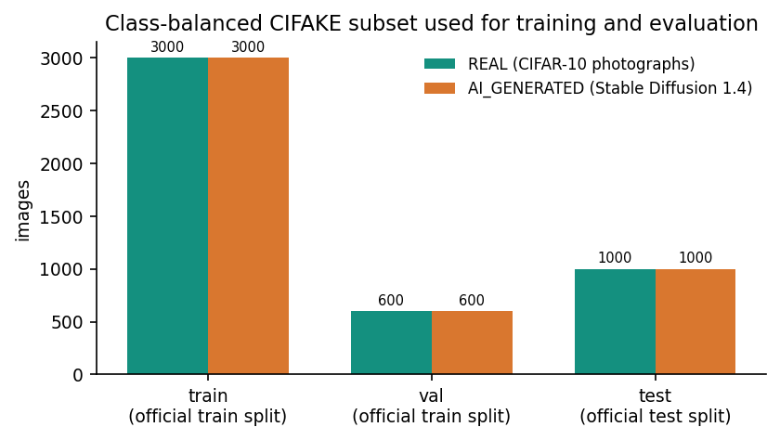
Figure 1: Size of the CIFAKE subset used for training, validation and testing (limitation: small, 32 px, one generator).
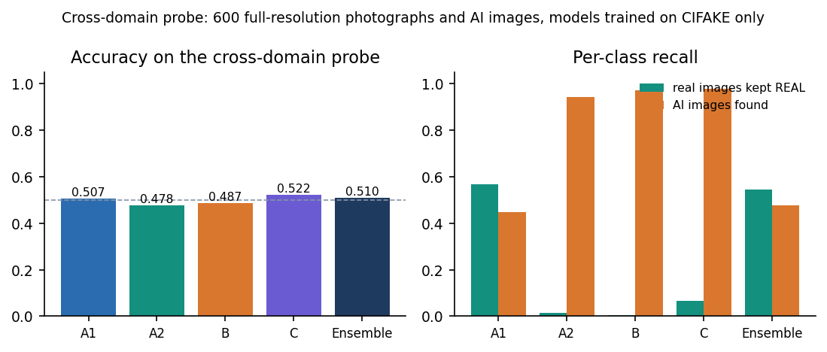
Figure 2: Cross-domain probe: accuracy of each route and of the ensemble on 600 images from another source (limitation: no cross-generator generalisation).

4. WHAT WAS NOT MEASURED
Some things that a complete evaluation would include were not measured. They are listed so that the absence of a number is not mistaken for a good result.
• A seed study: repeated training with different seeds and the spread of every metric.
• Training on the full CIFAKE training set, and on other generators (GAN, newer diffusion models) or higher resolutions, and a per-generator accuracy breakdown.
• A quantitative faithfulness test for Grad-CAM (deletion/insertion curves) and any user study of whether the heat maps help an analyst.
• Unit tests of explainability.py and robustness.py; load or concurrency testing of the API; behaviour under adversarial perturbations or attacks designed to fool the detector.
• GPU timing and the effect of quantisation; latency on machines other than the one described.
• A validated operating threshold, and calibration of the fused probability (for example temperature scaling).
• A like-for-like comparison with the base paper's method on its own datasets: the CTrue cross-dataset table is an image in the paper and was not quoted, and CTrue was not re-implemented.

